
Land Information Ontario (LIO) Warehouse
Data Class Name: Source Protection Area Generalized
Documentation
Produced by: Information Access and Information Management Policy Unit
Ministry of Natural Resources and Forestry
Date: July 27, 2015

Purpose

This document provides additional information to support the use of geospatial data. The Physical Model Diagram provides a visual representation of the relationships in the data class. The Data Change History lists all the modelling and access changes that have occurred during the lifecycle of the data class. A data description identifying table and field names is available upon request.

Need Assistance?
Please contact LIO Support at lio@ontario.ca or 705-755-1878 if you require help.

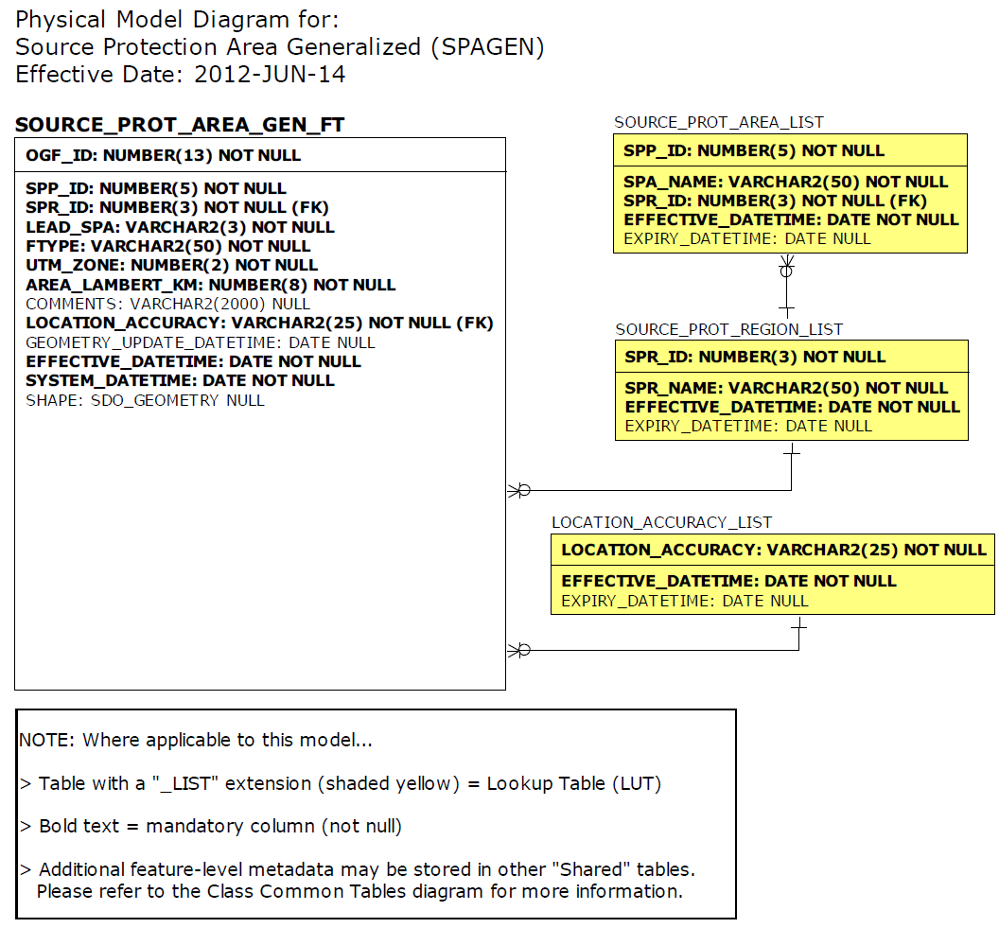

Data Class Change History

Data Class Name: Source Protection Area Generalized
Data Class Short Name: SPAGEN
Date  YYYY-MM-DD | Details of Change
2015-03-11 | Version 2.1 – Regulation amendment passed.  - Minor adjustment to align boundary with WHPA boundary within the Town of Mattawa.  Opens an image of the proposed source protection area change  - GEOMETRY_UPDATE_DATETIME field updated for all records in database according to historical loads into the LIO warehouse.
2011-04-15 | Columns dropped:  - SOURCE_PROT_AREA_GEN_FT.SPP_LINKID  - SOURCE_PROT_AREA_GEN_FT.SPA_NAME  - SOURCE_PROT_AREA_GEN_FT.AREA_UTMKM  - SOURCE_PROT_AREA_GEN_FT.SPR_NAME  - SOURCE_PROT_AREA_GEN_FT.AREA_LAM_M  Lookup Table Added: SPR_LIST  - SOURCE_PROT_AREA_GEN_FT.SPR_ID  - SOURCE_PROT_AREA_GEN_FT.AREA_LAMBERT_KM  Lookup Table value altered: SPR_LIST.SPR_NAME to remove spacing between the dash (-):  - Halton-Hamilton  - Mississippi-Rideau  - North Bay-Mattawa  Lookup Table added to SPA_LIST  Updated definition for SOURCE_PROT_AREA_GEN_FT.SPP_ID
2009-11-25 | Version 2.0 – Regulation amendment passed.  - Quinte SPA revisions implemented. The Source Protection Areas Moira River, Napanee, and Prince Edward have been merged to create one Source Protection Area called Quinte.  Opens an image of a proposed Source protection area called Quinte  - Addition of North Bay-Mattawa Lake/River polygon implemented, which incorporates a 1km buffer portion of Lake Nipissing including  Callander Bay.  Opens an image of the proposed source protection area change
2008-04-11 | NEW Data Class:  Version 1.0 – First LIO load of the cartographic version of the Source Protection Area Generalized Boundary (SPAGEN) to support Regulation 284/07 of the Clean Water Act.
Data Description
Please refer to the metadata record for the data description..

